**WOMEN RIGHTS**

**Surat An-Nahl (ayat-97):**

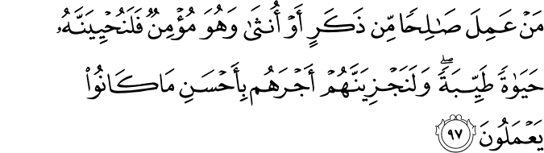

Whoever does righteousness, whether male or female, while he is a believer - We will surely cause him to live a good life, and We will surely give them their reward [in the Hereafter] according to the best of what they used to do.

**:**

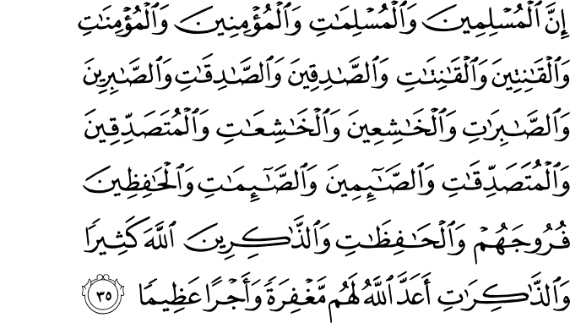

Indeed, the **Muslim** men and Muslim women, the **believing** men and believing women, the **obedient** men and obedient women, the **truthful** men and truthful women, the **patient** men and patient women, the **humble** men and humble women, the **charitable** men and charitable women, the **fasting** men and fasting women, the men who **guard their private parts** and the women who do so, and the men who **remember Allah often** and the women who do so - for them Allah has prepared forgiveness and a great reward.

**Surat An-Nisa (ayat-7):**

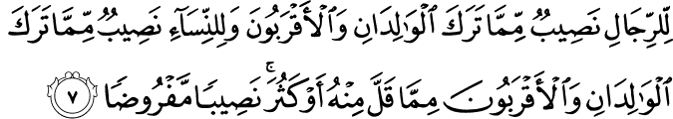

For men is a share of what the parents and close relatives leave, and for women is a share of what the parents and close relatives leave, be it little or much - an obligatory share.

**Right of non Muslim**

**Right of non Muslim in an Islamic state:**

A right of non Muslim is an Islamic state are as under:

1. Right to live
2. Protection of life, honor and property
3. Equal job opportunities in every filed in strength wise
4. Fulfillment of commitments.
5. Right to practice their own religious beliefs
6. Special relaxation granted on payment of taxes.

**Relation with non Muslim:**

It is the beauty of deen-e-Islam that its describes the rights of non-Muslim in an Islamic society and Islamic state Allah say:

“Allah does not forbid you to deal justly and kindly with those who fought not against you on account of religion nor drove you out of your homes. Verily, Allah loves those who deal with equity. It is only as regards those who fought against you on account of religion, and have driven you out of your homes, and helped to drive you out , that Allah forbids you to befriend them. And whosever will befriend them, then such are the Zalimun (wrong doers those who disobey Allah)”

**Explanation :**

The disbelievers who are not enemy and haven’t jealousy against Muslim and their religion, and who didn’t adopt any harsh way to the migration Muslims and those who haven’t plotted and supported against Muslim. The Muslim should deal such type of non Muslim kindly and justly.

**Treaty with Jews (meesaq-e-Madina):**

The Prophet Muhammad (p. b. u .h) himself made the treaty of Madina (meesaq-e-madina) with Jews. It was based on following conditions:-

**.** The expenses of war should become jointly.

. In case of any type of outside aggression, the city of madina should be defended jointly.

. Both Muslims and other people of madina should be treated as one nation.

. Free religious affairs would be allowed to the both parties.

. In case any major dispute between Jews and Muslims, the final decision will be taken by the

Prophet Muhammad (P.B.U.H)

**Treaty with Christian of Najran:**

History is witness that the Prophet Muhammad (P.B.U.H) also made the treaty with the Christian of Najran. According to this justice shall be made and their properties, life and religion will be protected. These both treaties indicate that Islam also cares for the rights of the non Muslim as well

If your enemy wants peace then you gave them positive response. Allah says:

“But if they (your enemy) incline to peace, you (also) incline to it, and (put your) trust in Allah. Verily, he is the all hearer, the all-knower”.

**Explanation:**

In this verse a fine principle has been stated that if your enemy inclines toward peace so you give them positive response towards peace. If the non Muslims want to cheat you then you should trust in Allah who knows and hears every thing. The Prophet Muhammad (P B U H) made the Jews part of the Muslim community and gave them equal right.

**Right of Women: -**

Islam gives the clear message to all that as a gender, (male and female) both are equal in the sight of Allah, but responsibilities and duties are mentioned separately. Basic principle about the rights is that every man and woman would be judge according to his/her faith and deeds.

**Allah Al-mighty says:**

**“whoever works righteousness whether male or female while he (or she) is true beliener (of islamic monotheism) verily, to him we will give a good life (in this world with respect, contentment and lawful provision), and we shall pay them certainly a reward in proportion tho the best of what they used to do (i.e paradise in the hereafter).”**

**Explanation: -**

The true believer male or female will get excellent worldly life. The one, who is person of character, will pass this as a pious person. He/She will worship, Allah Almighty alone and obey His order and will feel the taste of his/her faith, get the peace of mind satisfaction. Disbelievers and disobedient male or female will not get peace of mind in this world although they may be owner of a lot of wealth and beautiful palaces.

**Practical Link: -**

The believers will get success and lead happy life; they must prove practically that they have the firm faith in Allah and do the good deeds. In daily life if they display excellent character; Allah will give them honour in this world as well as in the life hereafter. The Holy Quran establishes equality between the male and female and mentions it clearly.

**Allah Al-mighty says:**

**“verily, the muslim (those who submit to allah in islam) men and women, the belivers men and women (who believe in islamic monotheism), the men and the women who are obedient (to allah), the men and women who are truthful (in their speech and deeds), themen and the women who are patient (in performing all duties which Allah has order and in abstaining from all that allah has forbidden), the men and the women who are humble (before their lord allah), the men an the women who are give sadaqat (i.e. zakat, and alms), the men an the women who observe saum (fast) (the obligatory fasting during the month random, and optional nawfil fasting), the men an the women who guard their chatity (from illefal sexual acts) and the men an the women who remember allah much with their hearts and tongues allah has prepared for them forgiveness and great reward (i.e. paradise).”**

**Explanation: -**

In this verse, a number of virtues[ ] have been mentioned. These all goods deeds are compulsory for both male and female. It also indicates that human rights and duties are also equal for both in this world as well as on the Dooms day.

**Practical Link: -**

Qualities of every Muslim man or woman are mentioned in this verse which demands that such qualities must be displayed practically in daily life. Islam has given by Allah in property of parents and nearest relative. Their shares are described separately.

**Allah says:**

**“There is share for men and a share for women from what is left by parents and those nearest related, wheather the property be small or large a legal share.”**

**Explanation: -**

It is a clear principle that has been describe in the verse. According to this law of inheritance, female will inherit as well as male in all the properties of parents, nearest related and husband as per rule that has mentioned in Surah Nisa verse no. 11 and 12. Allah Almighty says in Surah Nisa verse no. 34, men are the protectors and maintainers[ ] of women, because Allah has them more strength.

**Practical Link: -**

It is our duty as true believers to follow the Allah’s instruction and we must give the female her share in the properties of parents, husband and nearest related. We should care and look after all fundamental rights of woman in our daily life is commanded by Allah and we are also answerable to Allah if we deprive them of their due share.

SURAT AL-MUMTAHNAH:

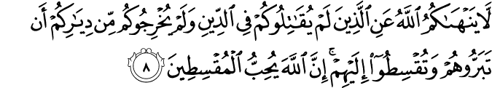

Allah does not forbid you from those who do not fight you because of religion and do not expel you from your homes - from being righteous toward them and acting justly toward them. Indeed, Allah loves those who act justly.

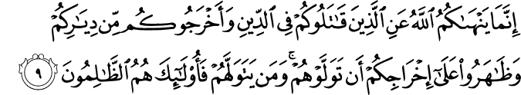

Allah only forbids you from those who fight you because of religion and expel you from your homes and aid in your expulsion - [forbids] that you make allies of them. And whoever makes allies of them, then it is those who are the wrongdoers.

SURAT ANFAL:

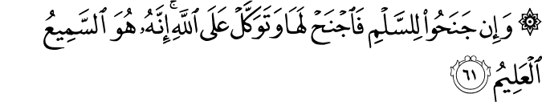

And if they incline to peace, then incline to it [also] and rely upon Allah . Indeed, it is He who is the Hearing, the Knowing.

**RELATION WITH THE NON-MUSLIMS**

Non-Muslims who did not make the Muslims target of their power were to be dealt with kindness. Almighty says:

*“Allah forbids you not with regard to those who fight you not for (your) faith, nor drive out of your home, from dealing kindly and justly with them; For Allah loveth those who are just Allah only forbids you, with regard to those who fight you for (your) faith, and drive you out of your homes, and support (others) in driving you out, from turning to them (for friendship and protection). It is such as turn to them (in these circumstances) that do wrong.*

*(Surah Al-Mumtahanah: 8-0)*

**Explanation:**

Even unbelievers, unless they are out to destroy us and our faith, should be dealt kindly and equitably, as is shown by our Holy Prophet’s (p.b.u.h.) by his own example.

The example of Hazrat Buraydah:

*When the Prophet appointed him commander over an army, great or small, lie would enjoin upon him more specially the fear of Allah, and upon the Muslims who. were with him, goodness; then would he say “March in the name of Allah. and fight with him who believes not in Allah: and march forth and defraud not, nor betray, nor mutilate, nor kill children or old men.”*

*(Sahih Muslim, Jania a Tirmizi)*

**Explanation:**

The non-Muslims have their rights and Islam recognizes these ‘rights without any reservation. The first and the most important commandment is that “La ikrah fil Dccii “. According to the Madina treaty made by the Prophet (p.b.u.h.) with the tribes of Al-Madina Muslims and the Jews were asked:

1. To bear the expenses of war.

2. To defend. Al-Madina against any aggression.

3. Both the Muslims and, other people of Yathrib (Al-Madina) constitute (one political) nation.

4. Beth are free in their religious affairs.

And Imam Shahab-ud-Din Zuhiry in Jarnia’a Tirmizi narrates:

The Prophet (p.b.u.h.) also divided booty among the Jewish people who fought for him.

There is another Hadith narrated by Hazrat Abu-Hurayrah.

“Do not give credit to the people of the Book, nor yet, call then? liars, but say: We believe in Allah, and what has been seizi down to US, and what has been sent down to Abraham and Jsmael and Ishaque and Jacob and the tribes, and what was given to Mztsa and Jesus, and what was given to the (other.) prophets, from their Allah... we mace no distinction between a oft hein and to Hint we submit

*(Sahih Bukhari,)*

This Hadith is similar to the 136 verse of Surah Al—J3aqarah In the 40 verse of Surah Al-Haff the Muslims have been advised to, defend themselves against oppressors, otherwise the freedom of worship in the churches, monasteries, synagogues, and mosques would end. These are the places where “the name of Allah is oft-Commemorated.

That is, complete assurance of religious freedom guiding not only Muslims but the whole mankind to respect religious freedom. Apart from the Al-Madina Tr (Misaq-e-Madina) the Prophet (p.h.u.h.) made anothu agreement with the Christen of Najran: which include the following terms:

*Never will they be humiliated Military service is not compulsory for them. Between them only justice shall their property, He religion, churches and all that they possess, little or much, will be protected.”*

That is the guideline set by Islam in respect of relations with the people having a different faith, culture, or system. The basic principle is that Islam “stands for peace for humanity at large and if there is an enemy who is determined to oppose this basic principle he must be dealt with properly. Even in this case restraint has been advised. The Holy Qur’an says:

*“But f the enemy inclines towards peace, so thou (also) incline towards peace, and trust in Allah, for He is the One that - heareth and knoweth (all things).*

*(Surah Al-Anfaal: 61)*

**Explanation:**

While we must always be read for a good light, lest it be forced on us, even in the midst of’ the fight we must always be ready for peace if there is any inclination towards peace on the other side. There is no merit in fighting by itself It should be a joyful duty not for itself but to establish the reign of peace and righteousness and Allah’s law:

There are many brilliant examples of cordial relationship between the Muslim and the non-Muslims in the early history of Muslims.

1. Every possible courtesy was shown to the Jews of Al-Madina by the Prophet (p.b.u.h.) and they werc made part of the Ummah of which the major partners were the Muslims;

2. The Prophet (p.b.u.h.) was so courteous with the visiting Christians from Habshah (Ethiopia) that he faced even their punching questions smilingly. He manifested an extra-ordinary patience and tolerance. Those Christians were not only lodged in the Prophet’s mosque but also allowed to say their own prayers. The Christians and non-believers, who used to come to exchange views with the Prophet (p.b.u.h.) were addressed in the mosque which also served as a guest house for these visiting learned men. The mosque was also used as a centre for teaching Islam.

3. During the reign of Hazrat Umar, the second Caliph, a house of a non-believer woman was acquired for the extention of a mosque in Egypt. The woman did not agree to give that and she lodged a complaint with the Caliph who immediately ordered to demolish the mosque and give back the possession of the land to the complainant.

4. When Hazrat Umar visited Palestine, it was suggested to him that he should offer his prayer in the Christian church. The Caliph refused to do so, on the plea that on his offering prayer in the church, the Christians could rightly think that the Muslims intended to occupy the place permanently. Here one is reminded of the Quranic instruction that places of prayers belonging to other religious communities should be respected and guarded.

The first and the last commandment is: let there be no compulsion in religion” (Al-Ba qarah 256) and verse 53 of Surah l3ani Israel reads: “Say to my servants that they should (only) say good things” According to the ‘renowned translator of the Quran, Allama Ahdullah Yousaf A this command refers to two situations.

1. Even to our enemies and the enemies of Allah, we should speak fair; who are to judge others? Judgement belongs to Allah alone for He knows you (i.e. all mankind).

2. Among ourselves also, we should not entertain suspicions, but speak politely according to the best standard of human speech. A false or unkind word may destroy all our effort of building up unity, because the forces of disruption are more numerous than the forces of Unit)’. In brief the message of Allah is that of universal unity.